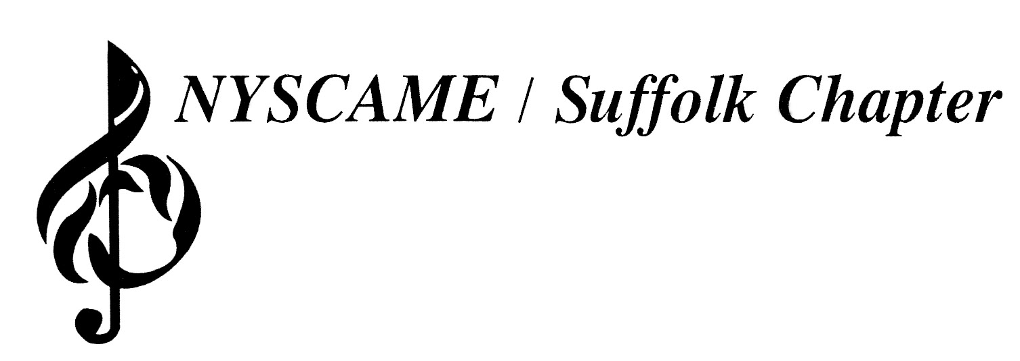

Dr. John Gallagher, President
Dr. Laura Landor, Professional Development Director
631-870-5781 (O)
631-870-5782 (F)
landorl@hauppauge.k12.ny.us

NYSCAME / SUFFOLK
2019-2020
Professional Development Program
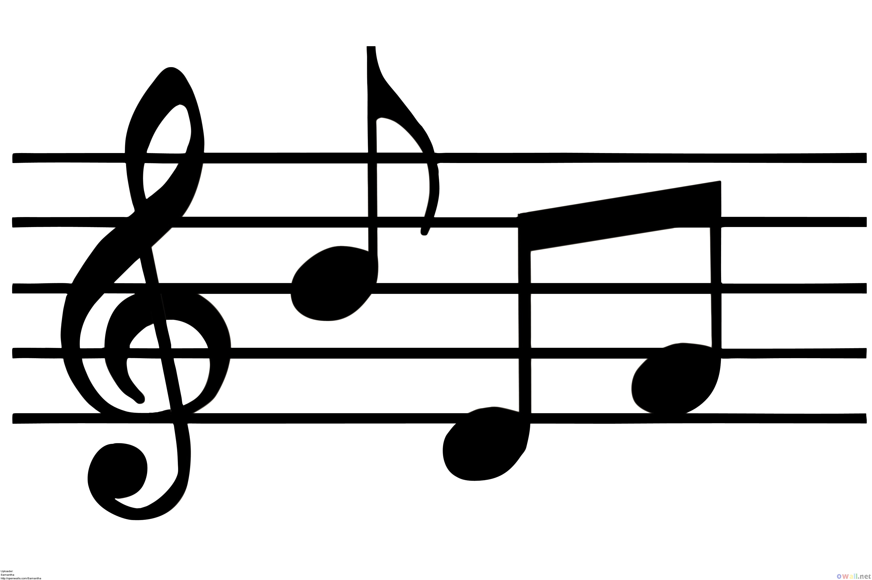
- Registration: Fax or scan/email to Dr. Laura Landor at the number/address above

- Participants’ school districts must be members of the NYSCAME/Suffolk Professional Development Series in order to attend at no-cost.

- Participants whose school districts do not participate in the Professional Development Series may attend these workshops for $25 per workshop, payable at the start of the workshop.

- Certificates of Completion will be distributed at the conclusion of each workshop.

NYSCAME/Suffolk 2019-20 Professional Development Program Registration Form
(Please type or print clearly)
Name: |  | School District:
Home Address:
Email: |  | Contact  Phone  Number

School District Member? Yes/No | Workshop Date | Workshop Name
1.
2.
3.
4.
5.
6.
7.
8.
9.

2019-20 NYSCAME Professional Development Workshops

Pease note that the locations are subject to change
All workshops are from 4pm-6pm

September 18, 2019 – Introduction to Conversational Solfege
Craig B. Knapp
Hauppauge Middle School

September 23, 2019 –Healthy Living for the Music Educator
Malcolm Gilbert
Bay Shore Middle School

October 2, 2019 –Timpani and Multiple Percussion in the School Setting
Dr. Dylan Benson
Hauppauge High School

October 21, 2019 – Score Marking for Excellence
Mark Tse
Suffolk County Community College (Ammerman Campus)

October 30, 2019 – Preparing Your Snare Drummers for NYSSMA
Frank Cannon
Hauppauge High School

November 13, 2019 – Horn Pedagogy for Non-Horn Players
Adam Wilbur
Longwood High School

February 5, 2020 – Feldenkrais for Musicians
Dr. Stephen Gorgone
Newfield High School

February 25, 2020 – Composition: Creating Music in the High School Theory Classroom
Dr. Frank Doyle
Northport High School

March 19, 2020 – Musical Theatre Singing
Steven Altinel
Walt Whitman High School

September 18, 2019 – Introduction to Conversational Solfege
Craig B. Knapp
Hauppauge Middle School

Conversational Solfege is a pedagogical method created by Dr. John Feierabend that develops musical literacy. Conversational Solfege develops an understanding of music through the use of rhythm syllables and solfege syllables at a conversational level, and then gradually evolves into traditional notation. Through carefully sequenced activities, Conversational Solfege enables students to joyfully assimilate the skills and content necessary to be musically literate. Patterns, folk songs, poetry, rhymes and classical music are the primary source materials that are used to develop those musical skills. This workshop will be geared toward elementary classroom music and choral teachers.

Craig B. Knapp (www.craigknappmusic.com) is an elementary choral and classroom music specialist. He has been teaching Classroom Music and Chorus, grades 3 through 5, at the Joseph A. Edgar Intermediate School in the Rocky Point School District since 1998. Craig is an Adjunct Assistant Professor at Hofstra University where he teaches “Conversational Solfege,” and he is the co-author of the book, “First Steps in Music with Orff Schulwerk: Sing, Say, Dance, Play" and a contributing author for the book "Feierabend Fundamentals." Craig is also the director of the Early Childhood Community Music Program at Stony Brook University, where he instructs children in Pre-K through 6th grade. With his innovative and energetic approach to music education, Craig Knapp also directs the Metropolitan Youth Orchestra of New York’s Children’s Treble Choirs, where he has conducted at historic music venues including Carnegie Hall and Lincoln Center.

September 23, 2019 –Healthy Living for the Music Educator
Malcolm Gilbert
Bay Shore Middle School

You’ve all heard the flight attendant tell you to secure your own mask before attempting to assist others, but in your day-to-day life, you’re not listening. Just how much can you help your students, colleagues and family if you’re not healthy? Attend this workshop for a discussion on the four pillars of health- diet, exercise, rest and personal fulfillment.

Malcolm Gilbert has spent the past 24 years in the Massapequa School District as the director of the Freshman Choir. Malcolm is an active private voice teacher, adjudicator, conductor, and guest speaker. He has presented workshops for the NYSSMA Winter Conference, Nassau-NYSCAME, SCMEA-NYSCAME, Balanced Mind Conference, and Hofstra University's ACDA and NAfMe chapters. He has been the featured guest on the Find Your Forte podcast. Malcolm is an original member of eVoco Voice Collective, and is an active freelance baritone. Away from the concert hall, Malcolm is an avid weightlifter and exercise enthusiast.

October 2, 2019 –Timpani and Multiple Percussion in the School Setting
Dr. Dylan Benson
Hauppauge High School
This clinic will focus on teaching techniques that will help the band director develop effective, inquisitive, and, most importantly, self-reliant timpanists and multiple percussionists in their percussion sections. Introductory NYSSMA solos for both timpani and multiple percussion will be presented and discussed.

Canadian percussionist Dr. Dylan W. Benson studied with marimba soloists Beverly Johnston and Sylvia Pimentel, Toronto Symphony Orchestra principal percussionist John Rudolph and Nexus members Russell Hartenberger and Robin Engelman. Upon being named a recipient of the prestigious Chalmers Award from the Ontario Arts Council, Dylan moved to New York to pursue a Doctorate of Musical Arts at Stony Brook University, a degree he completed in 2008. Dylan has worked with such composers as Phillip Glass and George Crumb, and frequently collaborates with East End Composers Eric Salzman, Stephen Dickman, and Victoria Bond. He has commissioned new works for percussion and piano, as well as percussion and electronics. His compositions have been recorded by the University of Toronto Percussion Ensemble and the Canadian Brass. Active as an orchestral musician, Dr. Benson was principal timpanist with the Scarborough Philharmonic, and has also performed with many of the major orchestras in Southern Ontario, including the Toronto Sinfonia, Toronto Chinese Choir, and the Kitchener-Waterloo Symphony. He has also performed with the Royal Winnipeg Ballet, as well as the Thunder Bay Symphony Orchestra, where he appeared as a marimba soloist. He can be heard on the CBC and Soundspells recording labels. Dylan is an active NYSSMA solo adjudicator, and has conducted HMEA and SCMEA festivals. Active memberships include NAfME, SCMEA, NYSBDA, and the Percussive Arts Society. He is the band and orchestra director at Nokomis Elementary School in the Sachem Central School District.

October 21, 2019 – Score Marking for Excellence
Mark Tse
Suffolk Community College

Score marking is an important component to score study and can serve as the springboard for deeper score study, leading to more efficient rehearsals and helping the conductor be more spontaneous during concerts. This workshop will address how teachers can create their own personalized systems of marking scores in clean and meaningful way.

Mark Tse is Director of Bands at SUNY Suffolk County Community College, conducting the Symphonic Band and Jazz Ensemble as well as teaching music history and theory. He is also a doctoral candidate in wind ensemble conducting with Timothy Salzman at the University of Washington. In the 2016 American Prize competition, he won 3rd place for community band wind ensemble conducting and an Honourable Mention for college/university wind ensemble conducting. In 2015, he won 2nd place for college/university wind ensemble conducting. Tse holds a Master of Music (wind ensemble conducting) from the New England Conservatory, a Master of Music (music education) from the University of Western Ontario, as well as a Bachelor of Music (music education) and a Bachelor of Education (instrumental music) from the University of Toronto. Previous to his graduate studies, Tse taught high school instrumental music for eleven years in the Toronto area, including concert bands, jazz ensembles, and classical guitar classes. Tse has also lead the Sistema Aeolian orchestras, modeled after the El Sistema program of Venuzuela that championed free music education for all children, regardless of socioeconomic class.

October 30, 2019 – Preparing your Snare Drummers for NYSSMA
Frank Cannon
Hauppauge High School

This workshop will teach you how to correct some of the common technical mistakes that snare drummers make. These mistakes leads to point deductions at NYSSMA and also limit the young percussionist from reaching his or her full potential. You will learn ways to improve your snare drummer’s NYSSMA score and improve the quality of your percussion section!

Frank Cannon received his undergraduate degree at the University of Miami and a Masters in percussion performance at Queens College. He was a band teacher in the Brentwood School District for 34 years and has recently retired. In Brentwood Frank also taught jazz band and conducted the high school musical. He taught and wrote drum parts for the three-time state champions Brentwood Green Machine drum line. He also wrote drum parts and cadences for over a dozen other drum lines on Long Island. Frank has also been a NYSSMA percussion judge since 1993. As a performer Frank is the percussionist for The Hamptons Festival Orchestra and has played in over 300 musicals in the Tri-State area including the Gateway, Engeman and Argyle Theaters. Frank has played with the rock band, The Mangos for the last 16 years as well as other rock and jazz bands in the area. Frank is the drummer for the open mic jazz jam at the Dunton Inn. Frank has recently completed a book on preparing snare drum, mallets, timpani , and multiple percussionists for NYSSMA sight reading.

November 13, 2019 – Horn Pedagogy for Non-Horn Players
Adam Wilbur
Longwood High School
This is a very thorough guide to understanding an instrument that most band directors are not comfortable teaching. After teaching and performing on the horn for over 20 years, I have aimed this workshop towards the most important aspects of the horn. This includes equipment, success strategies, technique, gear, and literature.

Adam is a High School Band Director in the Longwood School District. He is a proficient ukulele performer and arranger who has been very active in the ukulele community. He is a member of several forums and is an active participant at ukulele festivals.

February 6, 2019 – Feldenkrais for Musicians
Dr. Stephen Gorgone
Newfield High School

In this workshop, participants will be guided through various movement sequences in order to improve their mobility and better integrate their nervous and muscular systems. There will be discussions on the pertinent concepts of the Feldenkrais Method, its application to our well-being as musicians, and its methodology as applicable to improving one’s teaching. Participants should expect to leave feeling relaxed, revitalized with a greater sense of agency, and with the resources needed to continue improving oneself as an individual and as a teacher.

Dr. Stephen Gorgone is a professional violist, violinist, private music teacher, and Feldenkrais practitioner. He has taught music theory, music education, chamber music, and private lessons at Stony Brook University, Ithaca College, and throughout Long Island. A proponent of the Feldenkrais Method, he incorporates the methodology for healthier playing and a clearer teaching. He holds a Doctor of Musical Arts degree from Stony Brook University, where he studied with members of the Emerson String Quartet and Nicholas Cords of the Silk Road Ensemble, and is a Guild Certified Feldenkrais Practitioner. He also holds MM, BM, and BA degrees from Ithaca College in Viola Performance and Mathematics.

February 25, 2020 – Composition: Creating Music in the High School Theory Classroom
Dr. Frank Doyle
Northport High School
Musical elements that high school students explore in the theory classroom should be applied directly to the art of composition. This workshop will dig into several tried approaches and pedagogical techniques used for successful outcomes in reaching this rewarding creative goal. The application of music notation and sequencing software programs as they relate to the compositional process will also be discussed.

Dr. Frank Doyle was inducted into The LI Music Hall of Fame as the “Educator of Note 2016” for his pedagogical career in music theory, composition and musicology. His numerous literary contributions include the editing of Barron’s Review Book in AP Music Theory and co-writing of the 2014 National Standards in Secondary Music Theory and Composition. He is currently an editor for The Journal of Music Pedagogy Online and serves as program evaluator and workshop leader for NYSSMA, NAfME and the AP College Board where he presents lectures and training sessions on creative applications of popular music and music technology in the music theory curriculum. Frank has performed and recorded as keyboardist with Meatloaf, as musical director/composer with Weird Al Yankovic on his, “MTV’s Big Al Show,” and has scored original music for television, commercials and films. He plays piano with his quintet, “Lush Life” in jazz clubs throughout Long Island and NYC.

March 19, 2020 – Musical Theatre Singing
Steven Altinel
Walt Whitman High School
In this session, we will talk about the evolution of musical theatre singing from the "golden age" to what is now being considered the "platinum age." We will also discuss the sounds that are being heard on the musical theatre stage and how to explore these sounds with our students. This session will be interactive, encourage conversations about the art form, and include student performers.

Steven Altinel is the founder and artistic director of the Long Island Musical Theatre Festival. He maintains an active schedule as a music director, pianist and vocal coach in the tri-state area. Steven is often asked to present workshops on the topic of musical theatre at local and state conferences. In addition to this, he is the choral director of Walt Whitman High School where he has conducted his choirs on the stages of Carnegie Hall, and Alice Tully Hall of Lincoln Center. His favorite performance credits include the touring company of A Royal Christmas starring Andrea Bocelli and the New York Philharmonic’s production of Candide starring Paul Groves and Kristin Chenoweth (PBS). Steven performs regularly with the eVoco voice collective and is a proud graduate of Westminster Choir College.

