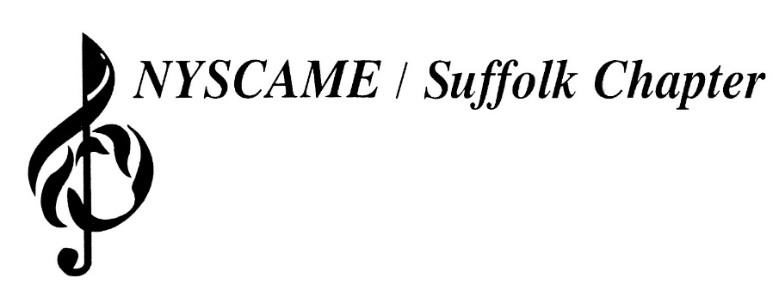
Dr. Robert J. Wottawa II – President

Dr. Michael Caravello – Vice-President
Jason Rottkamp– Secretary
Jon Trapani – Treasurer
Eric Albinder – Executive Director
Dr. Laura Landor – Professional Development Director
Jennifer Ross-Troise – Past-President

2023-2024 Meeting Dates
September 19, 2023 - All-County Music Distribution
October 17, 2023
November 14, 2023
January 9, 2024 - Honoring our Commercial Members
February 13, 2024 - Honoring our District Administrators
March 12, 2024 - Combined Nassau/Suffolk Meeting
Long Island Music and Entertainment Hall of Fame
97 Main Street
Stony Brook, NY 11790
11 am (optional)
Joint Meeting/Luncheon
The Jazz Loft
275 Christian Avenue
Stony Brook, NY 11790
12 pm
April 9, 2024 – Honoring our Secretaries and Assistants
May 14, 2024
June 11, 2024 – Honoring our Scholarships Recipients
All meetings begin at 12:00 PM.
All meetings are at the Irish Coffee Pub, unless otherwise noted.
This year’s cost per meeting is $40 per person.
IRISH COFFEE PUB
131 Carleton Ave.
East Islip, NY 11730

