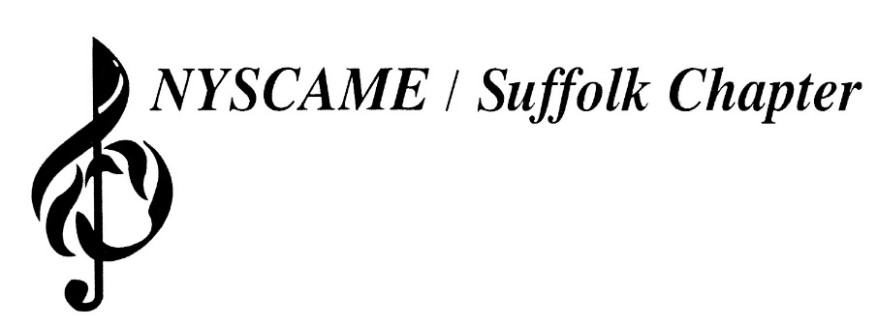
Dr. Robert J. Wottawa II – President

Dr. Michael Caravello – Vice-President
Jason Rottkamp– Secretary
Jon Trapani – Treasurer
Eric Albinder – Executive Director
Dr. Laura Landor – Professional Development Director
Jennifer Ross-Troise – Past-President
August 2023

Invoice
District/Institution Name: ______________________________________

Director/Liaison Name: _______________________________________

District Address: ____________________________________________

__________________________________________________________

School Participation Fee 2023-2024…………………………………..........$150.00
***PLEASE NOTE: Participation in all NYSCAME/Suffolk Chapter activities (including All-County, scholarships, transportation to All-State and All-Eastern, meetings and workshops) is reserved exclusively for teachers and students of participating districts.
Additionally, all districts wishing to participate in any NYSCAME and SCMEA music festivals for the 2023-24 school year must provide a district chaperone at all rehearsal sites. No student(s) will be allowed to participate without an official district chaperone on site for the entire duration of the rehearsal/event.
Checks are payable to: NYSCAME/Suffolk
Mailing address:
NYSCAME/Suffolk – Jon Trapani, Treasurer
Fran Greenspan Admin Center
525 Half Hollow Road
Dix Hills, NY 11746
School participation fees are due on or before Friday, October 6, 2023.
Thank you for your participation!

